System design – Starting from scratch or integrating new equipment
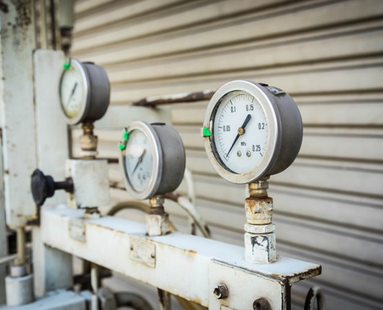

If you are in the fortunate position of starting a production or servicing facility in a newbuild unit then you have the luxury of planning a compressed air system from the ground up. Most of us however must work within the confines of an existing system and develop it to suit the evolving needs of the business.
- Is your existing pipework the right size?
Undersized piping restricts the flow and reduces the discharge pressure, thereby robbing the user of expensive compressed air power.
- Poor pipe routing can cause problems.
A piping system with tight turns may cause pressure loss through turbulence. You need to run the piping as straight and smooth as possible. Tee Unions added to accommodate new machinery can have the same effect. Planning the routing of pipework at an early stage can help overcome the problems of bolting on inefficient junctions later on.
- Is your compressor able to handle your additional needs?
Undersizing the compressor leads to higher maintenance costs as well as premature failure. Sizing the entire system with an understanding of expected air flow demand is critical.
- Do you have adequate air storage?
The value of a suitably sized air reservoir is often underestimated. Their primary function is storing and delivering compressed air to help meet periods of peak demand preventing excessive compressor usage. You may need to consider smaller tanks close to new machines or in areas where air flow demands may spike or be intermittent.
An example of a recent problem that we heard about was a small bottling plant who had moved production units, uprooting all his old pipework, compressor and other components to take with him. His new site had a longer run of pipework including some in an unheated area. Production ground to a halt as his compressor was not delivering an adequate flow in the new environment and additional water vapour had caused valves on his dispensing machines to become corroded. Some initial planning and design guidance based on the new working space would have saved him considerable time and expense.
Harrier Pneumatics believe in designing and producing to meet your requirements. We design and produce systems to interlock with your existing installations. We can provide circuitry design to suit your production requirements. Working with your production and maintenance teams we can design and build expansions to existing systems that make the most of your existing facilities while taking account of increased demands. If you are in the position of starting a compressed air installation from scratch we can assist you in futureproofing the system to let production expand as your business grows. Get in touch to discuss how we can help you create or expand your compressed air system.

